**Game Logic**

**1. Game Objects**

**Ball**

* Properties:
  + Position (x, y)
  + Velocity (dx, dy)
  + Size (radius)
* Behavior:
  + Move based on velocity
  + Bounce off walls and paddles
  + Reset position when a point is scored

**Paddles**

* Properties:
  + Position (x, y)
  + Size (width, height)
  + Speed
* Behavior:
  + Move up and down within screen boundaries
  + Collide with the ball

**Score**

* Properties:
  + Player 1 score
  + Player 2 score
* Behavior:
  + Increment when a point is scored
  + Reset when starting a new game

**2. Game Loop**

1. Update ball position
2. Check for collisions (ball with walls, paddles)
3. Update paddle positions based on user input
4. Check if a point is scored
5. Update score if necessary
6. Redraw all game objects
7. Repeat steps 1-6 until the game ends

**3. Collision Detection**

**Ball-Wall Collision**

* If the ball hits the top or bottom wall, reverse its vertical velocity (dy)
* If the ball goes past the left or right edge, award a point and reset the ball

**Ball-Paddle Collision**

* If the ball's x-position is within the paddle's x-range and its y-position is within the paddle's y-range:
  + Reverse the ball's horizontal velocity (dx)
  + Optionally, adjust the ball's vertical velocity (dy) based on where it hit the paddle (for more dynamic gameplay)

**4. Scoring System**

* If the ball passes the left edge, Player 2 scores a point
* If the ball passes the right edge, Player 1 scores a point
* After scoring, reset the ball to the center with a random direction

**5. Paddle Movement**

* Player 1 (Left Paddle):
  + Move up when 'W' key is pressed
  + Move down when 'S' key is pressed
* Player 2 (Right Paddle):
  + Move up when Up Arrow key is pressed
  + Move down when Down Arrow key is pressed
* Limit paddle movement to stay within the screen boundaries

**6. Game States**

* Start: Display title screen, wait for user input to begin
* Play: Main game loop is active
* Pause: Freeze game state, display pause menu
* Game Over: Display final scores, option to restart or quit

**7. Additional Features (Optional)**

* Increase ball speed gradually as the game progresses
* Add power-ups (e.g., temporary paddle size increase, ball speed change)
* Implement AI for single-player mode
* Add sound effects for ball hits, scoring, and game events

1. **PFB Snippets of Game**
2. Start Menu

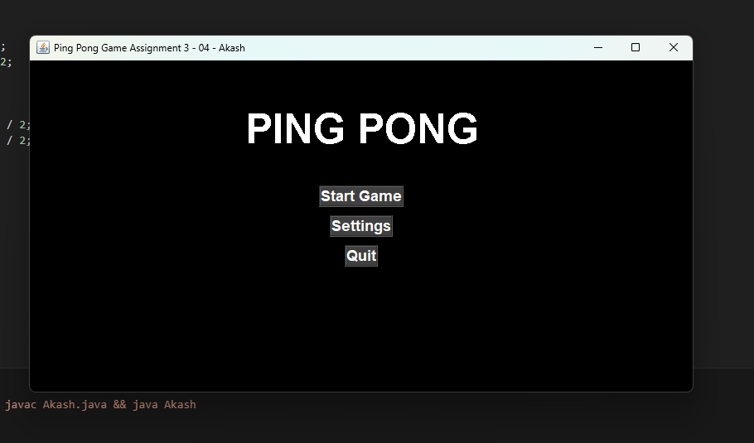

1. Game Panel.

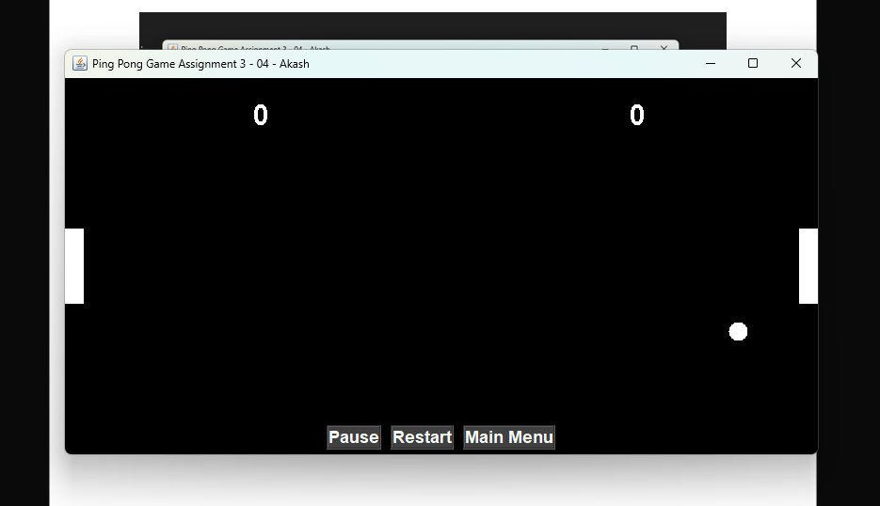

1. When Game is Paused.

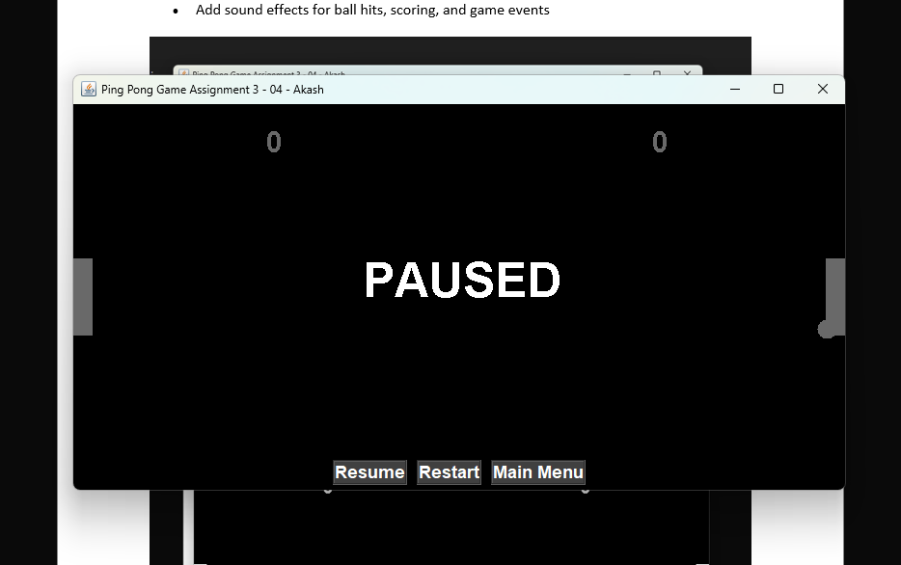

1. Game Setting.

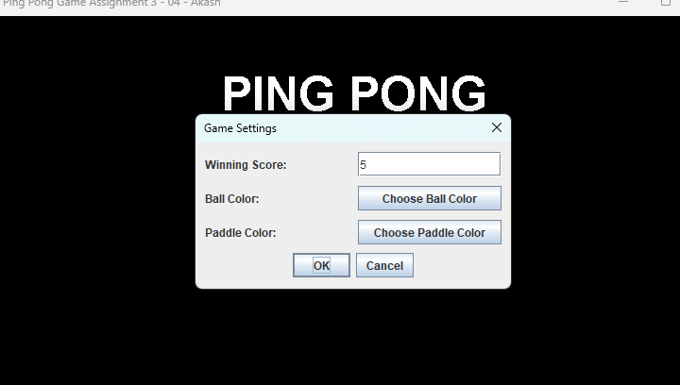

1. Game Setting to change Ball and Paddle Color.

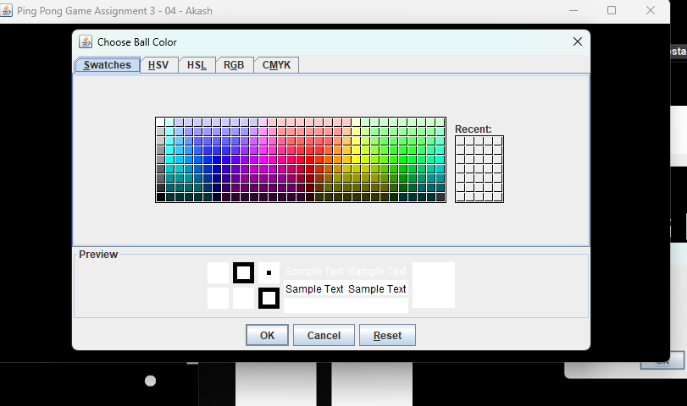

1. Option After winning the game.

